**FDI Approval in 2004-2005**

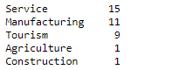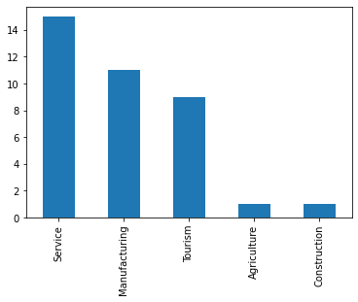In 2004-2005, I have found that there are **37 companies** registered under **five categories.**

There are 17 countries that have registered their companies in Nepal. India tops the list with 10 companies followed by China, Japan, Germany, UK and so on.

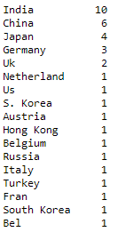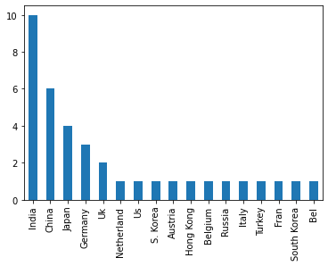

According to the Foreign Investment amount, we can see that India have the highest amount of foreign investment.

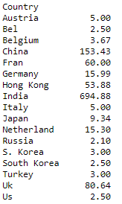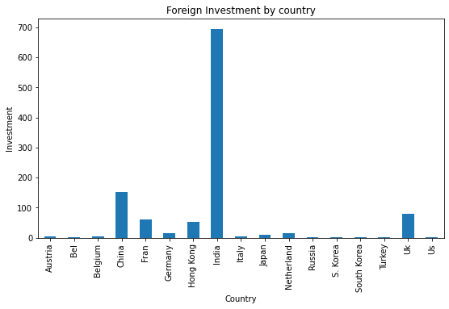

If we see Foreign Investment with respect to Categories, we can find that highest amount of Investment is for the Service Sector.

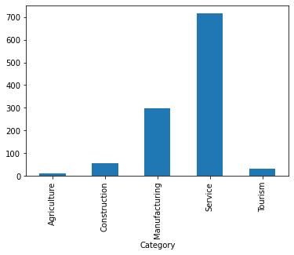

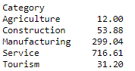

**FDI in 2005-2006**

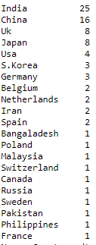In 2005-2006, we can see that there are altogether 85 companies registered by 21 countries. Here India tops the list with 25 companies followed by China, UK, Japan and so on.

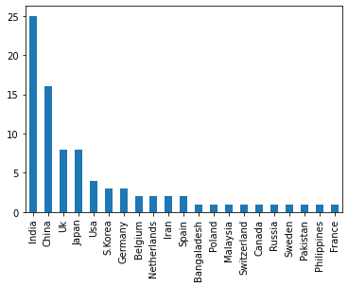

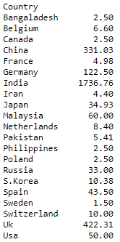If we see Foreign Investment with respect to country, India tops the list with 1736.76 million Rupees.

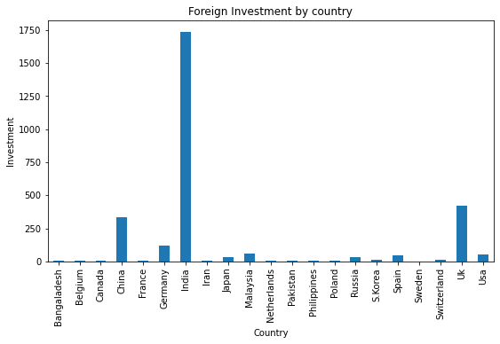

If we compare Foreign Investment with respect to its Categories, we found that most of the Investment are for Manufacturing Sector.

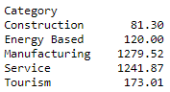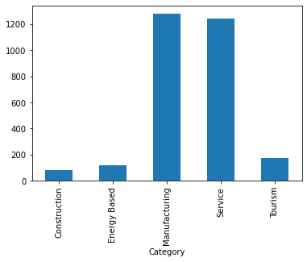

If we compare number of companies registered with respect to its categories, we found that Service Sector have more number of companies than other sector.

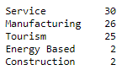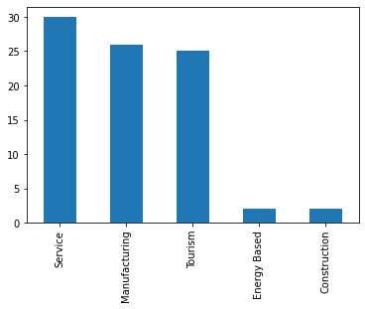

**FDI in 2006-2007**

In 2006-2007 we found that, there are more number of companies registered for Service Sector followed by Tourism and others.

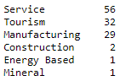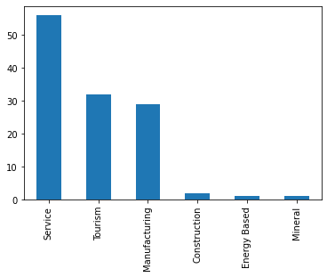

we can see that there are altogether 121 companies registered by 25 countries. Here China tops the list with 25 companies followed by India, Japan and so on.

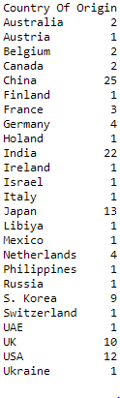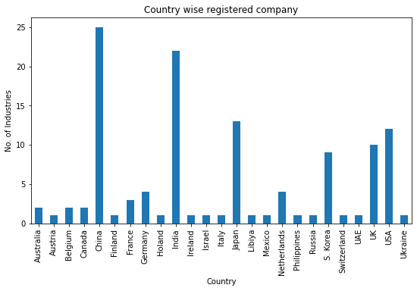

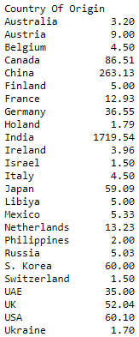If we see Foreign Investment with respect to country, India tops the list with 1719.54 million Rupees.

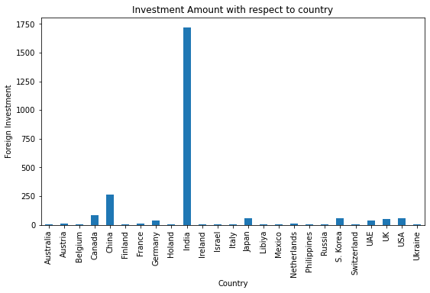

If we compare Foreign Investment with respect to its Categories, we found that most of the Investment are for Manufacturing Sector.

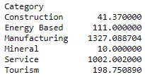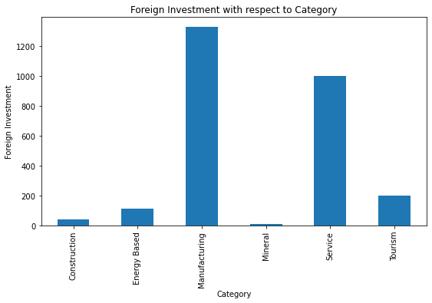

**FDI in 2007-2008**

In 2007-2008 we found that, there are more number of companies registered for Tourism Sector followed by Service and others.

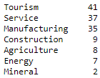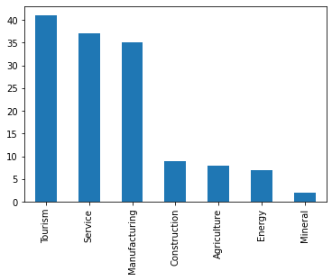

we can see that there are altogether 139 companies registered by 33 countries. Here India tops the list with 29 companies followed by S. Korea, China and so on.

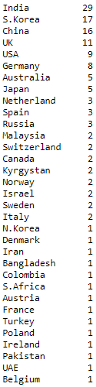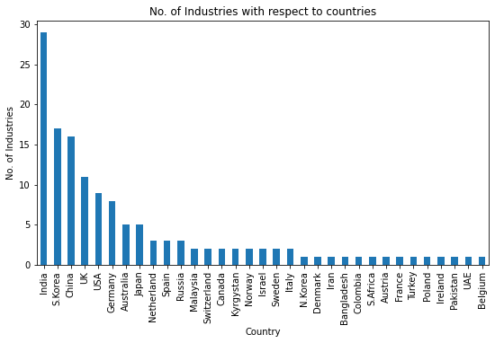

If we see Foreign Investment with respect to country, India tops the list with 3490.93 million Rupees.

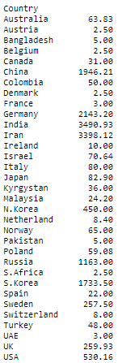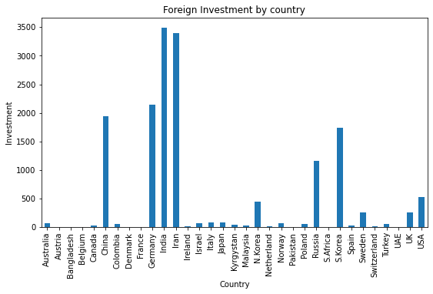

If we compare Foreign Investment with respect to its Categories, we found that most of the Investment are for Energy Sector.

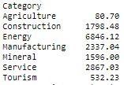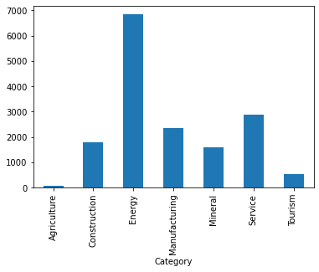

**FDI in 2008-2009**

In 2008-2009 we found that, there are more number of companies registered for Tourism Sector followed by Service and others.

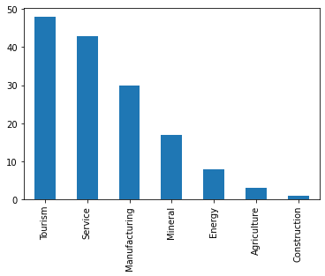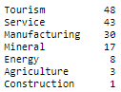

we can see that there are altogether 150 companies registered by 29 countries. Here China tops the list with 51 companies followed by India, UK and so on.

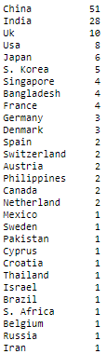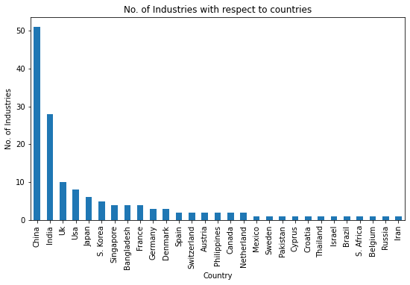

If we see Foreign Investment with respect to country, India tops the list with 3887.239 million Rupees.

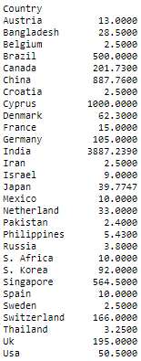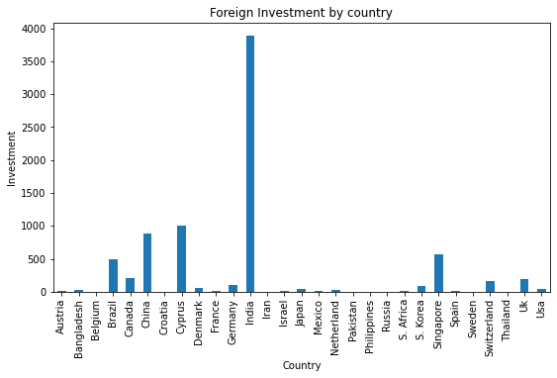

If we compare Foreign Investment with respect to its Categories, we found that most of the Investment are for Energy Sector.

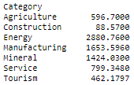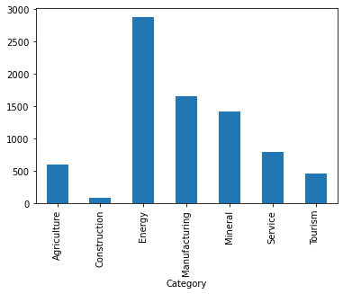

**FDI in 2009-2010**

In 2009-2010 we found that, there are more number of companies registered for Service Sector followed by Tourism and others.

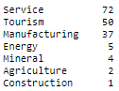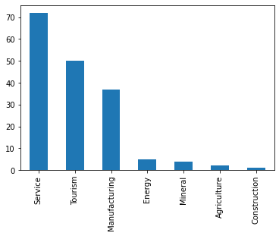  
we can see that there are altogether 171 companies registered by 35 countries. Here China tops the list with 59 companies followed by India, S. Korea and so on.

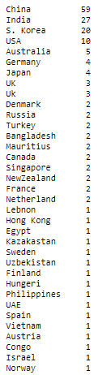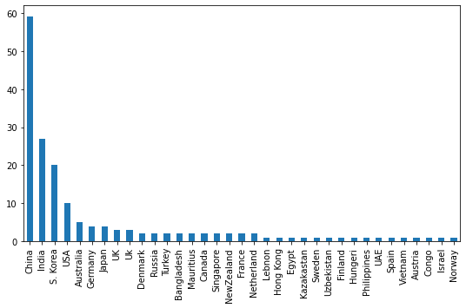

If we see Foreign Investment with respect to country, India tops the list with 77895.25 million Rupees.

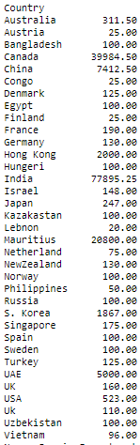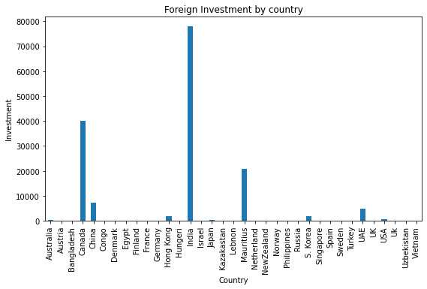

If we compare Foreign Investment with respect to its Categories, we found that most of the Investment are for Energy Sector.

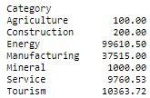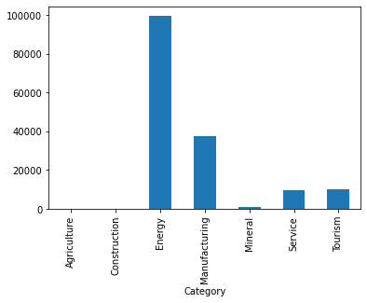

**FDI in 2010-2011**

In 2010-2011 we found that, there are more number of companies registered for Service Sector followed by Tourism and others.

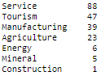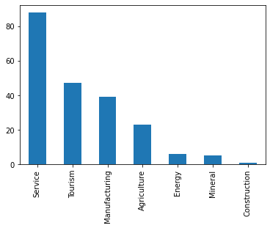

we can see that there are altogether 209 companies registered by 36 countries. Here China tops the list with 69 companies followed by India, S. Korea and so on.

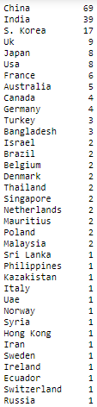 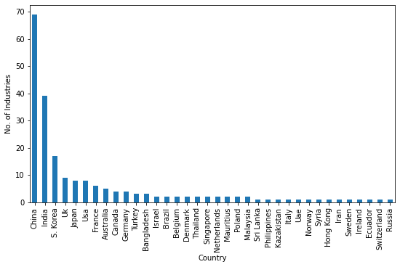

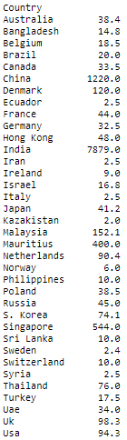If we see Foreign Investment with respect to country, India tops the list with 7879 million Rupees.

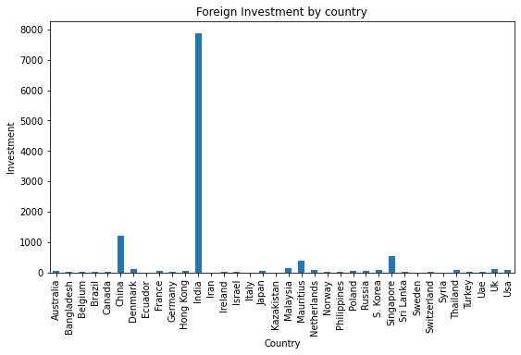

If we compare Foreign Investment with respect to its Categories, we found that most of the Investment are for Manufacturing Sector.

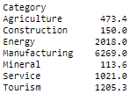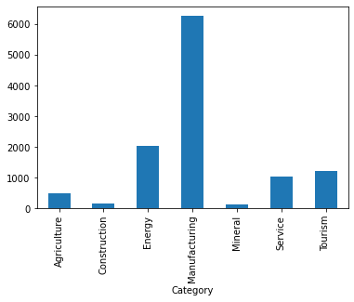

**FDI in 2011-2012**

In 2011-2012 we found that, there are more number of companies registered for Service Sector followed by Tourism and others.

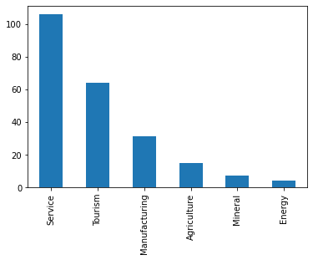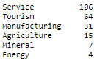

we can see that there are altogether 227 companies registered by 38 countries. Here China tops the list with 77 companies followed by India, S. Korea and so on.

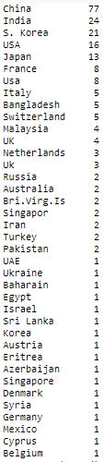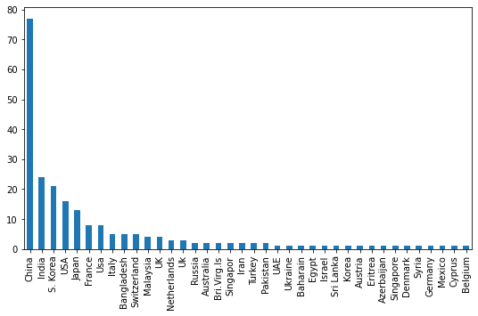

If we see Foreign Investment with respect to country, India tops the list with 3887.8 million Rupees.

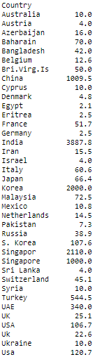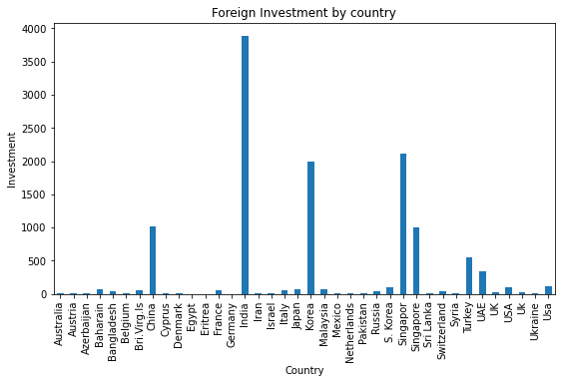

If we compare Foreign Investment with respect to its Categories, we found that most of the Investment are for Energy Sector.

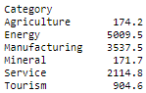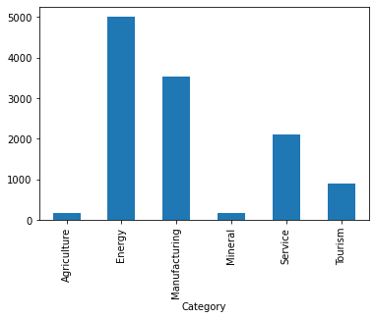

**FDI in 2012-2013**

In 2012-2013 we found that, there are equal number of companies registered for Tourism and Service Sector followed by Manufacturing and others.

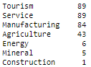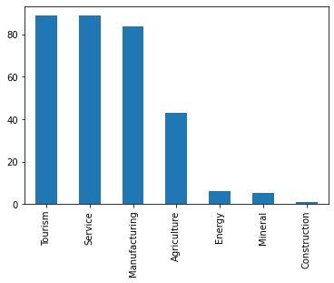

we can see that there are altogether 317 companies registered by 43 countries. Here China tops the list with 97 companies followed by India, USA and so on.

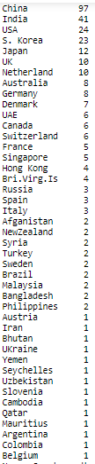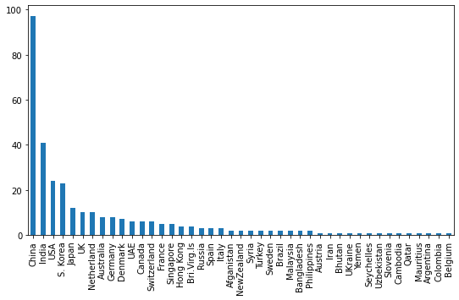

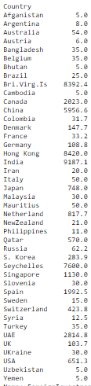If we see Foreign Investment with respect to country, India tops the list with 9187.1 million Rupees.

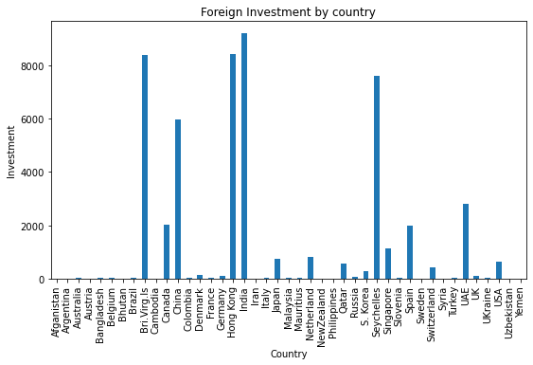

If we compare Foreign Investment with respect to its Categories, we found that most of the Investment are for Manufacturing Sector.

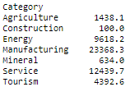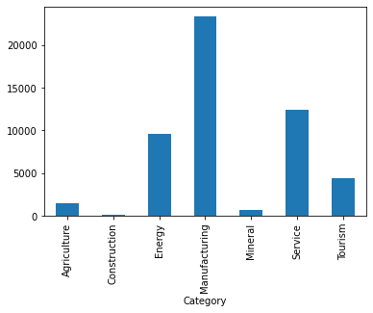

**FDI in 2013-2014**

In 2013-2014 we found that, there are more number of companies registered for Service Sector followed by Tourism and others.

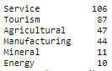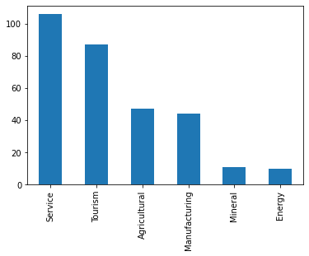

we can see that there are altogether 305 companies registered by 49 countries. Here China tops the list with 119 companies followed by USA, S. Korea and so on.

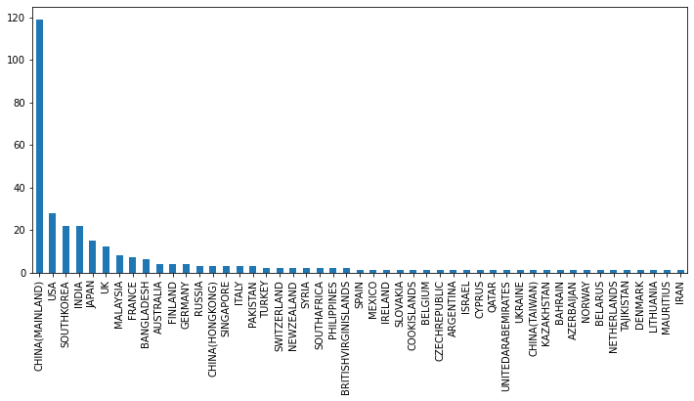

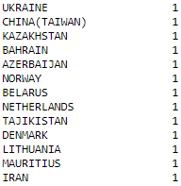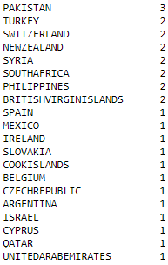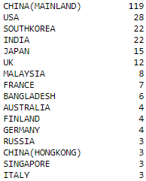

If we see Foreign Investment with respect to country, China tops the list with 7314.4388 million Rupees.

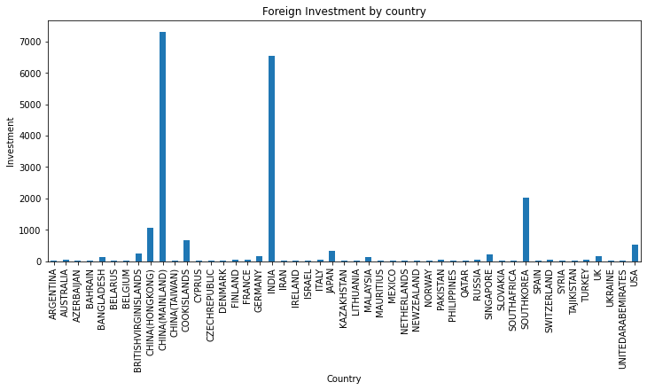

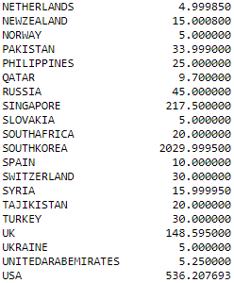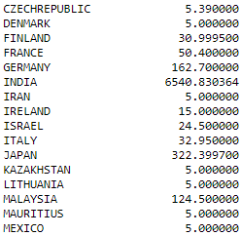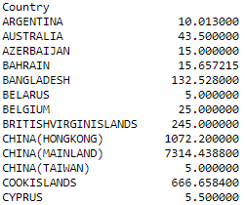

If we compare Foreign Investment with respect to its Categories, we found that most of the Investment are for Energy Sector.

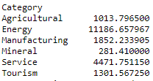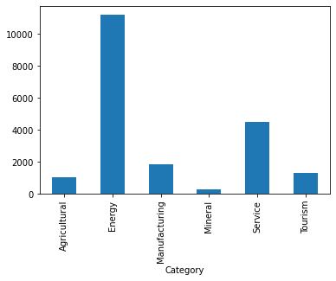

**FDI in 2014-2015**

In 2014-2015 we found that, there are more number of companies registered for Tourism Sector followed by Service and others.

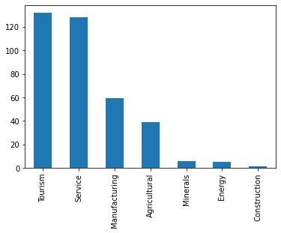

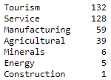

we can see that there are altogether 370 companies registered by 44 countries. Here China tops the list with 153 companies followed by USA, S. Korea and so on.

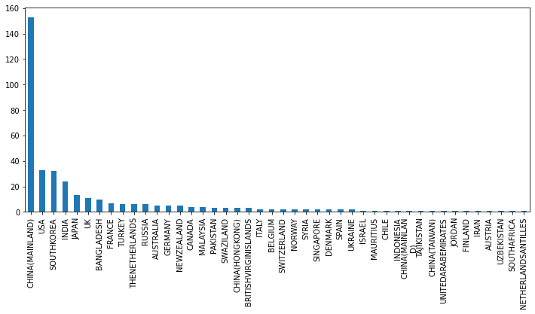

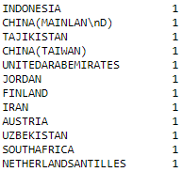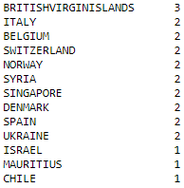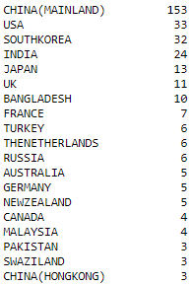

If we see Foreign Investment with respect to country, China tops the list with 34515.129168 million Rupees.

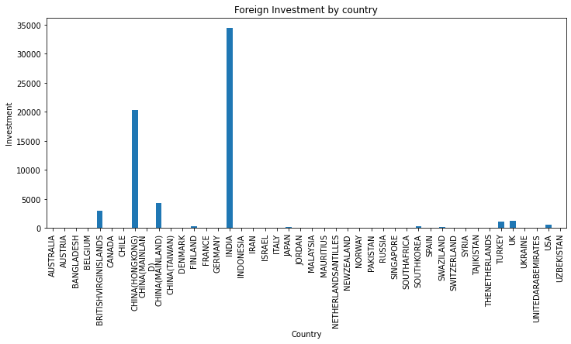

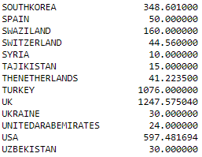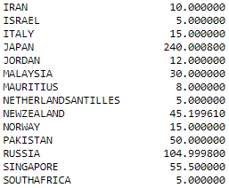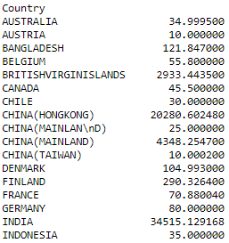

If we compare Foreign Investment with respect to its Categories, we found that most of the Investment are for Energy Sector.

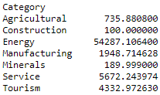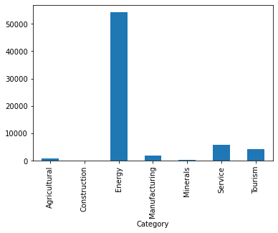

**FDI in 2015-2016**

In 2015-2016 we found that, there are more number of companies registered for Service Sector followed by Tourism and others.

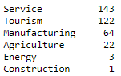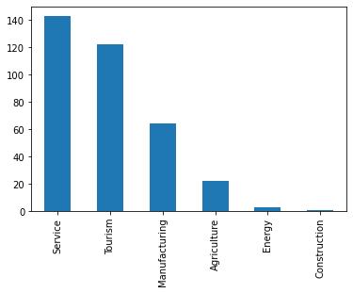

we can see that there are altogether 355 companies registered by 36 countries. Here China tops the list with 132 companies followed by S. Korea, USA and so on.

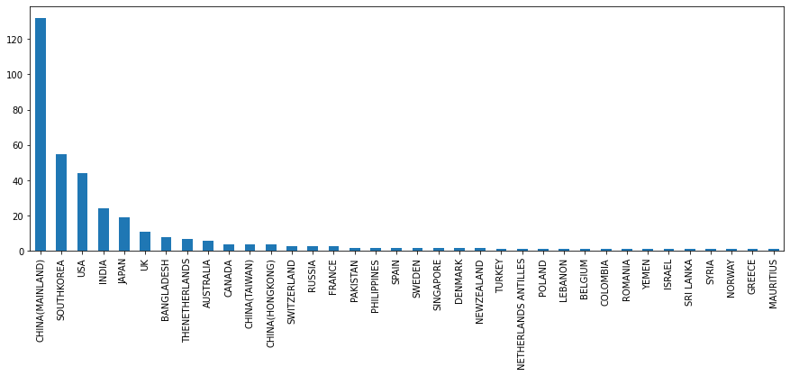

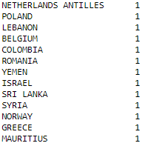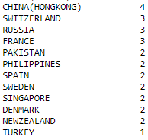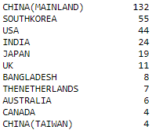

If we see Foreign Investment with respect to country, China tops the list with 34515.129168 million Rupees.

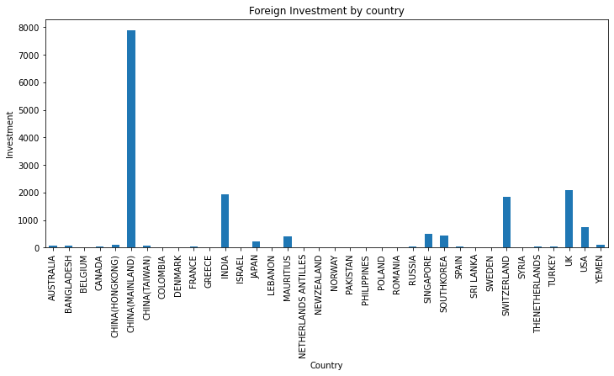

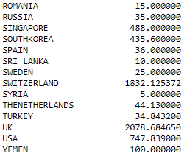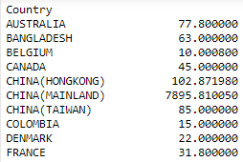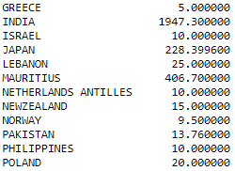

If we compare Foreign Investment with respect to its Categories, we found that most of the Investment are for Service Sector.

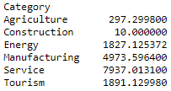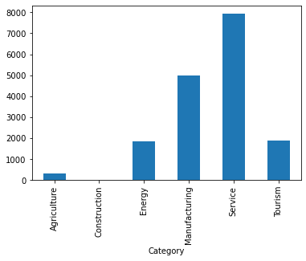

**FDI in 2016-2017**

In 2016-2017 we found that, there are more number of companies registered for Service Sector followed by Tourism and others.

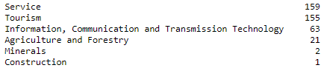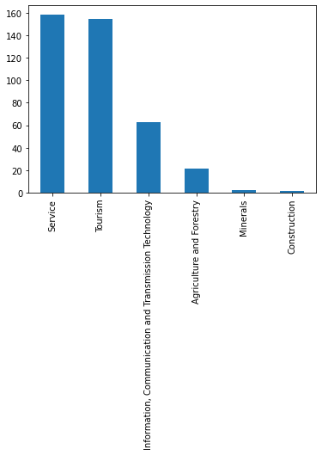

we can see that there are altogether 399 companies registered by 41 countries. Here China tops the list with 186 companies followed by India, USA and so on.

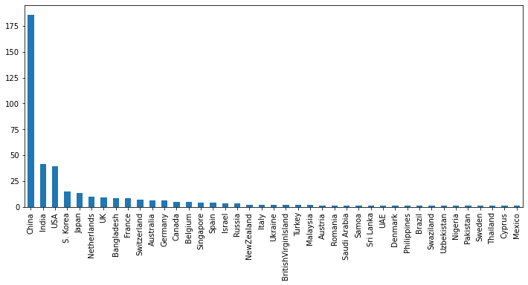

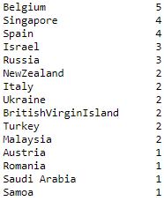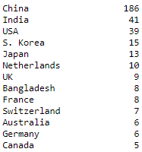

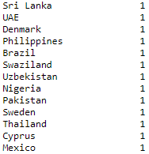

If we see Foreign Investment with respect to country, China tops the list with 8356.76 million Rupees.

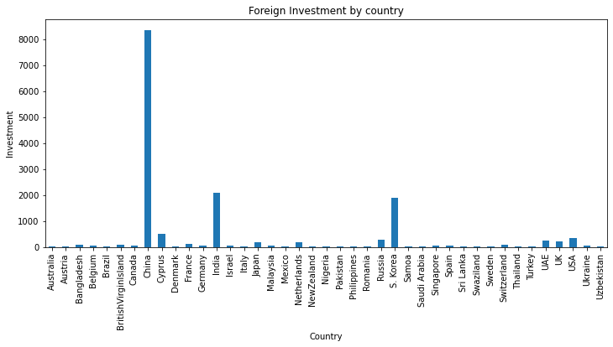

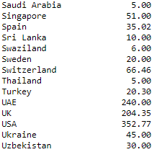

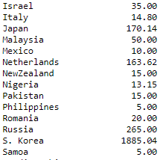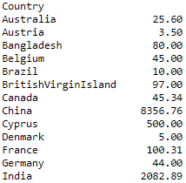

If we compare Foreign Investment with respect to its Categories, we found that most of the Investment are for Tourism Sector.

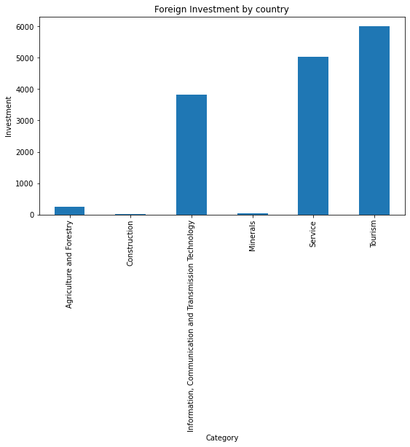

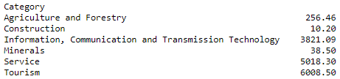

**FDI in 2017-2018**

In 2017-2018 we found that, there are more number of companies registered for Tourism Sector followed by Service and others.

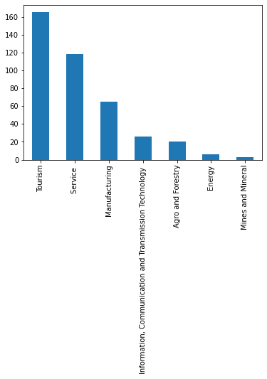

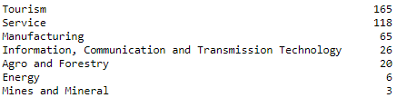

we can see that there are altogether 397 companies registered by 45 countries. Here China tops the list with 162 companies followed by India, USA and so on.

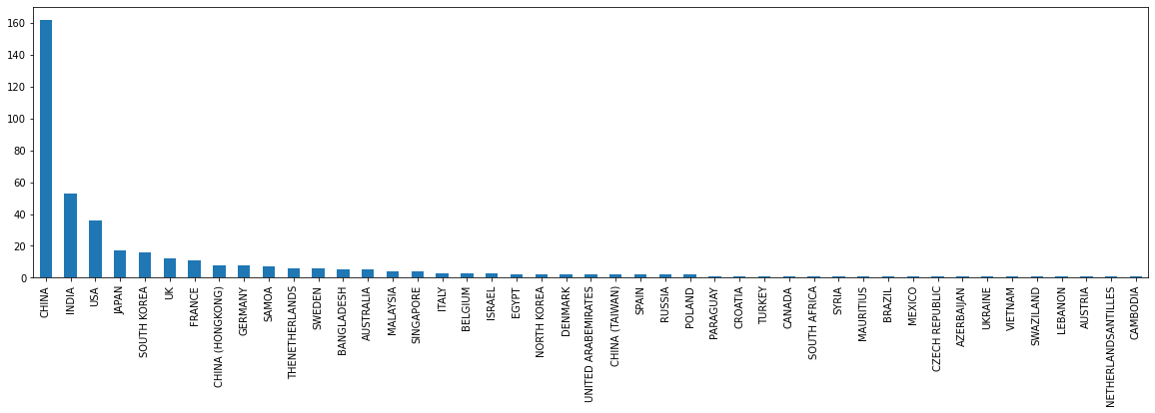

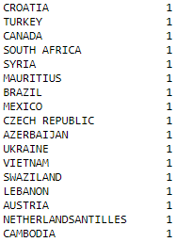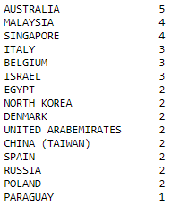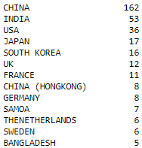

If we see Foreign Investment with respect to country, China tops the list with 46541.94 million Rupees.

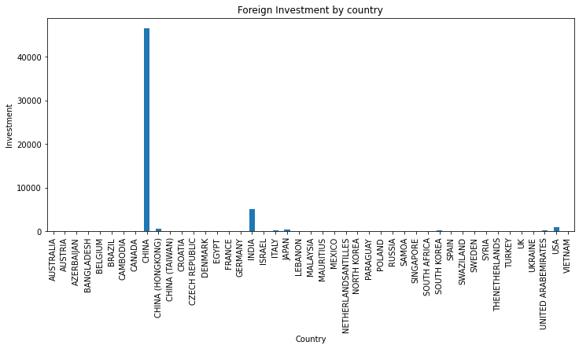

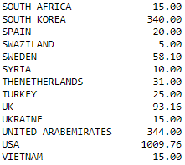

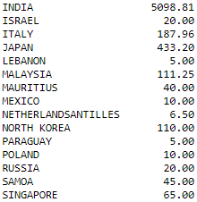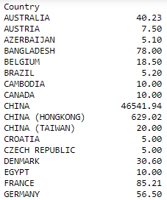

If we compare Foreign Investment with respect to its Categories, we found that most of the Investment are for Energy Sector.

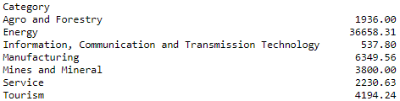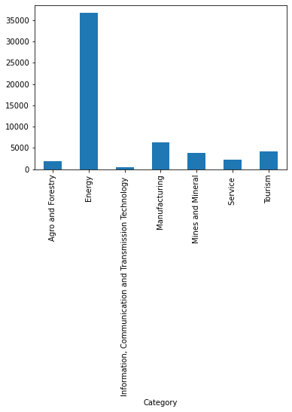

**FDI in 2018-2019**

In 2018-2019 we found that, there are more number of companies registered for Tourism Sector followed by Service and others.

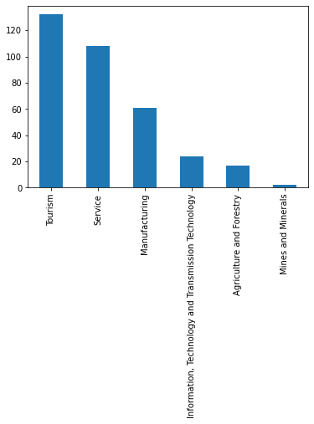

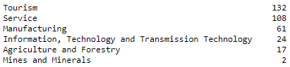

we can see that there are altogether 342 companies registered by 30 countries. Here China tops the list with 173 companies followed by India, S. Korea and so on.

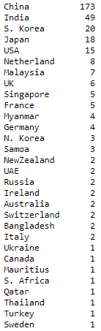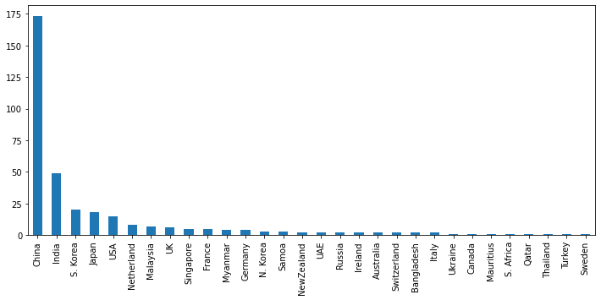

If we see Foreign Investment with respect to country, China tops the list with 13886.9486 million Rupees.

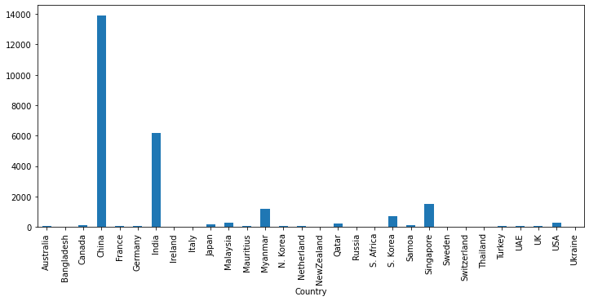

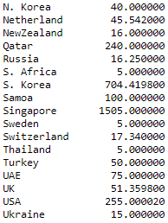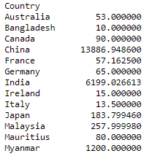

If we compare Foreign Investment with respect to its Categories, we found that most of the Investment are for Tourism Sector.

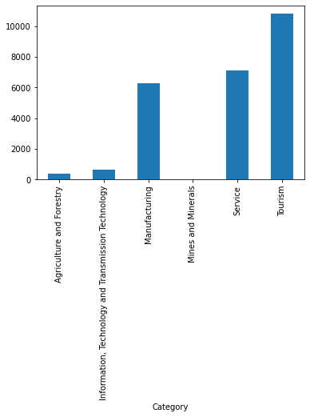

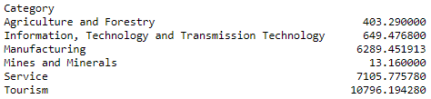

**FDI in 2019-2020**

In 2019-2020 we found that, there are more number of companies registered for Tourism Sector followed by Service and others.

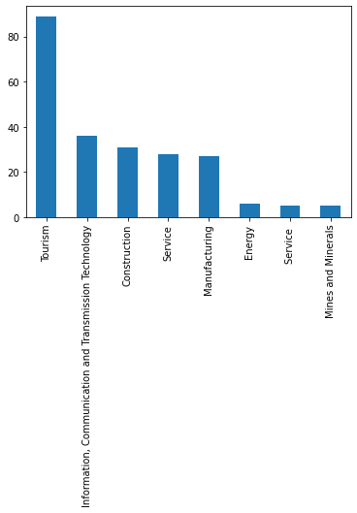

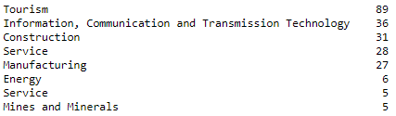

we can see that there are altogether 225 companies registered by 17 countries. Here China tops the list with 175 companies followed by India, UK and so on.

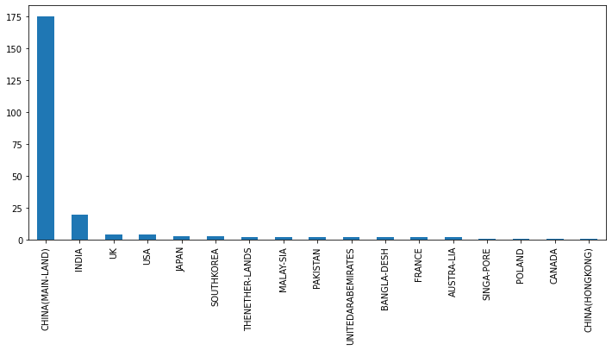

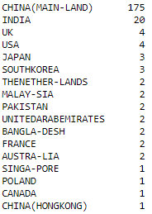

If we see Foreign Investment with respect to country, China tops the list with 25332 million Rupees.

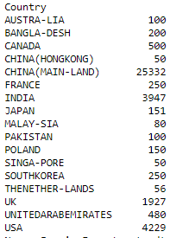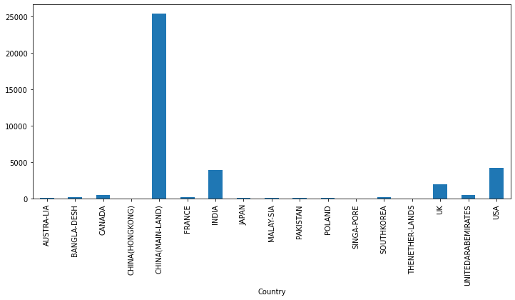

If we compare Foreign Investment with respect to its Categories, we found that most of the Investment are for Tourism Sector.

